A TRIBUTE TO THE FALLEN

"TWO VILLAGES"

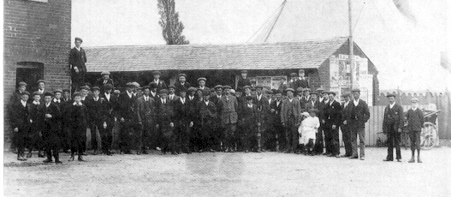
The young men of the village at the Lion 1910

They are just two small villages close to the Essex coast. Both feature in the Domesday Book but are minute specks on the map for all that. At the start of last century, one had 46 families and the other 49. This is the story of their young men.
EDWARD FELGATE 2nd Dragoon Guards 1 /9/1914
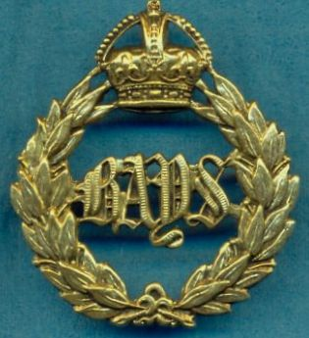The 1st World War was barely a month old before the loss of Edward. He was the son of the local baker. Edward was 22 years old and in the cavalry, serving in the 2nd Dragoon Guards. During the retreat from Mons, "L" Battery of the Royal Horse Artillery came under attack by German cavalry at Nery. The 2nd & 5th Dragoons rode to the rescue and 12 German guns were captured. 3 VCs were awarded for this action, all to the RHA and there were some 17 of the Dragoons killed, including Edward. One wonders was he any less courageous than those awarded the medals.

CLAUDE SAWKINS RN HMS Hawke 15/10/1914
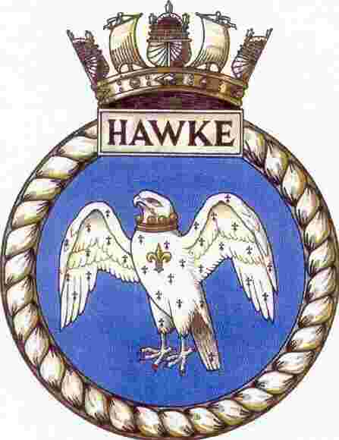October 1914 saw the death of Claude. He was a 17 year old boy seaman on H.M.S. Hawke. She was sailing with another old obsolete cruiser, H.M.S. Theseus in the North Sea. U-boat, U9 missed Theseus with a torpedo but with her second hit H.M.S. Hawke in the magazine. H.M.S. Hawke sank quickly and only managed to launch 1 lifeboat. H.M.S. Theseus was under orders from the Admiralty not to stop for survivors. Sadly a few weeks before H.M.S. Aboukir had been torpedoed and when H.M. Ships Crecy & Hogue had gone to her aid, they too in turn had been sunk. There were just 49 survivors from H.M.S. Hawke, sadly Claude was not among them.
PERCY MORTLOCK Northamptonshire Regiment 14/3/1915
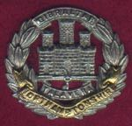Percy was the local paperboy only sixteen years old. He had joined the TA at the outbreak of war. Six months later he fell in March 1915, at the Battle of Neuve-Chapelle serving with the Northamptonshires.

LEONARD MINNS Suffolk Regiment 18/4 / 1915
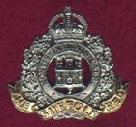Only a month later, Leonard, a Suffolk boy working originally on Langenhoe Wick Farm, fell with the Suffolk Regiment just a few miles from Percy.

ARTHUR RADFORD Essex Regiment 7/5/1915
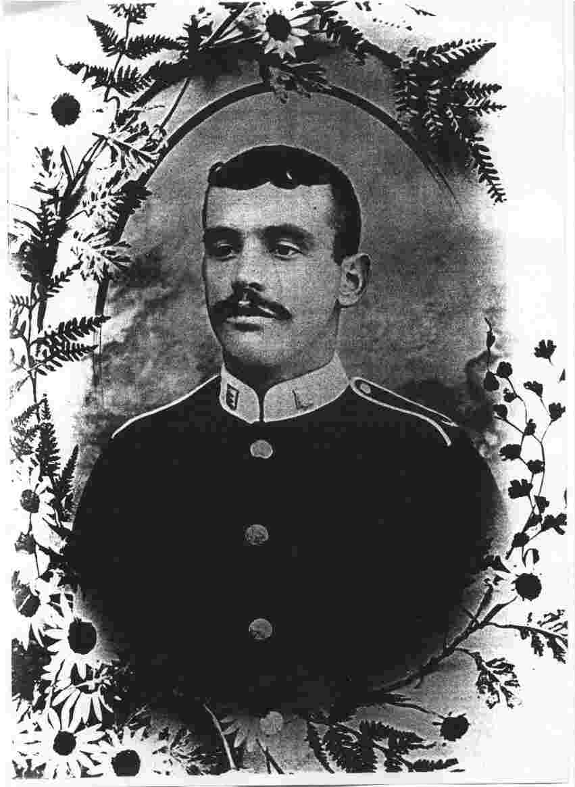1915 also brought Gallipoli and more sorrow for the villages. Arthur was a regular soldier, who had served in India with the 1st Battalion, the Essex Regiment. Arthur was 25. The battalion was committed to the vicious hand to hand fighting at Krithia, at the start of the campaign in early May. Arthur along with 700 other British died here along with many French and Turks.
ERNEST FRYER H.M.S Vengeance 15/6/1915
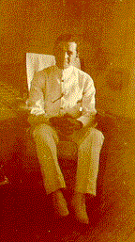Ernest was a farmer’s son, who ran away to sea at the age of 12. He became a sailor on the old sailing ships. In 1912, he was commissioned, as a sub- lieutenant in the RNR. He served on the old battleship, H.M.S. Vengeance taking part in the bombardment of the Turkish forts, as the fleet tried to force passage through the Dardenelles. However, they were at anchor some days later, when Ernest was involved in trying to fight a ship board fire. He was badly burned and succumbed to his wounds. In naval tradition he was buried at sea, just off the coast.
The epitaph to Arthur & Ernest was written by Mustapha Kemel, the Turkish commander:-

"Those heroes that shed their blood and lost their lives…you are now lying in the soil of a friendly country, therefore rest in peace. There is no difference between the Johnies and the Mehmets to us, where they lie side by side, here in this country of ours….You, the mothers, who sent their sons from far away countries wipe away your tears. Your sons are now lying in our bosom and are in peace. After having lost their lives on this land they have become our sons as well".

One year after the war began, there were only 8 able-bodied men between 18 and 40, left in Abberton. While Langenhoe had only 7. The rest had gone into the Services and more were to follow.

EDWARD HUGHES Durham Light Infantry 16/09/ 1916

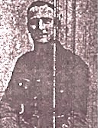1916 brought the Battle of the Somme. Edward was a Captain with the Durham Light Infantry and had been fighting 2 years. He was wounded leading his men forward on his 30th Birthday and died the next day.

CLIFFORD WYNCOLL Royal Field Artillery 3/11/ 1916
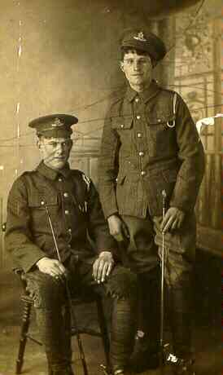 Clifford, shown here on the right, was just 18 and serving as a farrier with the Royal Field Artillery. He had already served the best part of 2 years and had been with the horse teams close to the action throughout the long battle that had raged since July. It was November and he was going home for leave to see his parents. They sheltered in an old barn with a leaking roof. It was here he caught a cold, that rapidly turned to pneumonia. He died in Calais.

CLIFFORD GREENLEAF Royal West Kent 26/11/ 1916
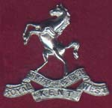There was a second Clifford, who lived in a neighbouring house. Both their fathers were farm workers. This Clifford was just 19. He had joined the 8th Battalion the Queen’s Own Royal West Kents and gone to France in August 1915. He fought at Loos and subsequently on the Somme. His battalion lost 300 men near Trones wood in that August. However, it was 26th November that he was killed during a period of "relative inactivity".

ARTHUR BROOKES East Surrey Regiment 22/03/1916
& his brother
DAVID BROOKES Royal Fusiliers 24/04/1917
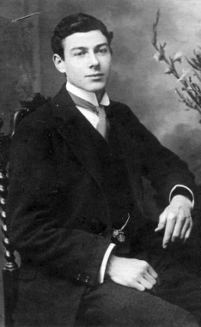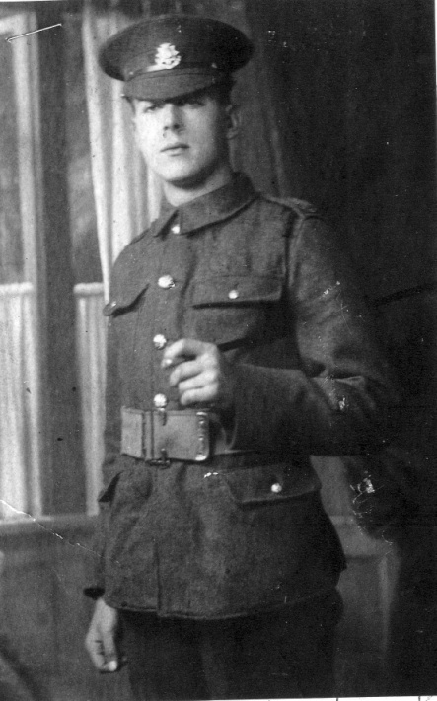 Martha Mountford had been born in Langenhoe and went away to work in London, where she was a maid in the Churchill household. She raised a family only to return to Langenhoe when her husband died. Now the war took 4 of her sons away to fight & was to bring a double sorrow. First, her son Arthur (on the left) was killed in March 1916 with the East Surrey’s at the Hohenzollern Redoubt. He had already been previously wounded patched up & sent back to die.
His brother David was killed whilst serving with the Royal Fusiliers at the Battle of Arras in April 1917.
ROWLAND RADFORD Northamptonshire Regiment 10/05/1917

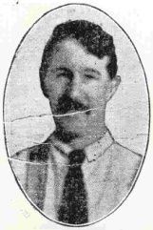Rowland had been a Kitchener volunteer at the start of the war. He had been drafted into 5th Northamptonshires and sent to France with a spade. The 5th were a pioneer battalion sent to dig trenches and graves, mend roads and all the other support functions necessary to sustain the Army. They were in the thick of the fighting and when the infantry were taken out of the line in rotation for a rest, the pioneers often had to stay on to repair defences. Rowland was shot in the knee and brought back to Saint Thomas’s Hospital in London. They patched him up and sent him back. Next time, he was hit by shrapnel in the shoulder. Again he was patched up and again returned. At Arras, as the infantry went forward, so did Rowland and the other pioneers, to put in communication trenches to the newly won positions. It was here that Rowland fell. Sadly, Rowland who had been brought up by his Grandmother was no longer able to support her. Now she lost her sole means of support and had to be placed in the Workhouse.
GEORGE WRIGHT Essex Regiment 7/07/ 1917
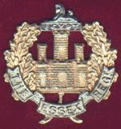George was 41 and a married man. He had been called up into the Training Battalion of the Essex Regiment. However, he was not a hundred percent fit and had been transferred to the Agricultural Corps. They worked on the farms to help produce food. Unfortunately, George caught pneumonia and died in July 1917. George’s grave is here at Saint Andrew’s
BENJAMIN WENDON Essex Regiment 24/07/1917
Ben was also a relatively old man, at 32 and was a married man with two children. He fought with the 13th Battalion of the Essex Regiment. He had fought on the Somme and subsequently in the bitter fighting in Delville Wood. They were also involved in the Ancre Offensive. He died in the front line just south of Arras on July 24th 1917.
JAMES THOMSON Royal Fusiliers 28/03/1918
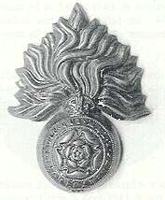James family had come down from Scotland and settled at Butler's Farm. He served with the Royal Fusiliers and died at Arras in the desperate attempts to block a major German offensive. His body was not recovered and like Rowland , his name is commemorated at the Arras Memorial.
DAVID BAWTREE Black Watch 29/6/ 1918
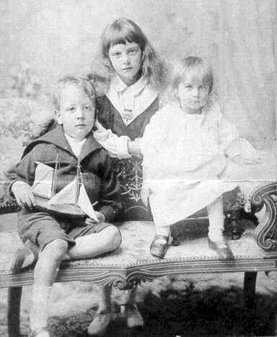
David was the son of the local gentry. He had originally joined in January 1915 and been commissioned. David was wounded and sent home to be invalided out of the Army. Against his mother’s wishes, he agitated to get back and joined the 6th Battalion of the Black Watch as a private. They were part of the 51st Highland Division, who had an awesome reputation but likewise suffered terrible casualties. The circumstances of his death are not clear but it appears he was captured in the severe fighting around Cambrai in March 1918 and subsequently died of wounds as a POW. He lies in the German Cemetery at Denain.

GEORGE COLLISON RFA 24/12/1918
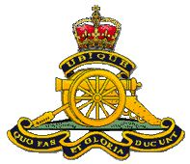George, who had served with the Royal Field Artillery died on Christmas Eve just 6 weeks after the fighting stopped. He was buried at Saint Sever near the hospital where he was being treated at Rouen

OSWALD THEOBALD Royal Engineers 23/11/1919
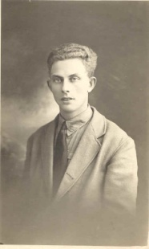

One casualty of World War 1, who died later of wounds was Oswald. He had served in a tunneling company of the Royal Engineers. They carved tunnels under German positions to set high explosive charges. Towards the end of the war, in March 1918, they had been blowing bridges around Peronne to halt the German advance. This meant waiting till the last remnants of the rearguard crossed before pushing the plunger and then scuttling back under fire. Oswald was discharged in November 1918, as "wounded in action - no longer fit for military service". They gave him a pension of eleven shillings a week. Unfortunately, Oswald died a year later of his wounds and he too rests at Saint Andrew’s.
CHARLES ARNALL Royal Fusiliers 21/03/1918
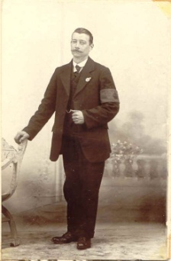
Oswald's elder sister, Ivy, had married a draper's clerk from Islington named Charles. He had joined the Royal Fusiliers and been killed on the first day of the final German onslaught, March 21st 1918. He is buried at Chauny Communal Cemetery.
STANLEY FENN CLARKE Honourable Artillery Company 11/1/1920

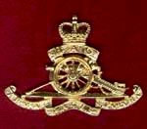Stanley had served with the Honourable Artillery. He came home with post traumatic stress. Unable to cope and haunted by terrible nightmares of his time at the Front, he took his own life at the start of 1920

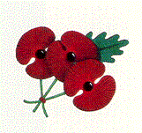
WORLD WAR TWO
Twenty years later and the families had to face World War 2. There were no illusions. The parents knew war very well and now they had their sons and daughters in the Services. And they were at risk.
CLARENCE WHITFIELD RAFVR 13/8/1941
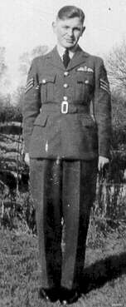
Clarence was the first to die. He was only 21 and had worked with the Post Office. A bomber pilot in a Halifax, he served with 76 Squadron. His plane was shot down over Bremerhaven by a night fighter on the 13th August 1941. Although, the crew managed to parachute out. They fell in the water and drowned before they could be saved.
ROBERT COPPIN RAFVR 21/10/1941
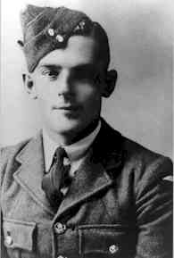
Robert was also RAFVR. He was married with a young son and was 27 years old. The bus he was traveling in whilst coming back from town was full of RAF personnel. It crashed into a parked lorry & the bus’s petrol tank caught fire. Sadly few of them survived.
ALPHA WILKIN RN HMS Jupiter 10/03/1942
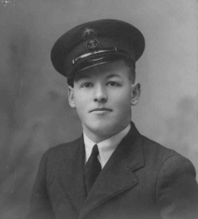

Alpha was a steward serving on a destroyer, H.M.S. Jupiter. H.M.S. Jupiter was in the thick of the action. The ship was involved in the evacuation from Norway, fights in the Channel, and action against destroyers in the Bay of Biscay. Bombardment of Genoa was followed by a transfer to the Med. Fleet. They had only been there a few weeks, when they were sent as escorts for H.M. Ships Prince of Wales & Repulse en-route for Singapore. They escorted the last convoy from Singapore, the last tankers to leave Sumatra and went back for the rearguard. They sank a Japanese submarine, which had been forced by a depth charge to the surface. As H.M.S. Jupiter closed with the damaged sub, the Japanese heroically tried to man their gun. As men were shot, others ran to take their place, until H.M.S Jupiter finally finished her with another depth charge. Only 2 Japanese survived. Then came the Battle of the Java Sea, with the loss of many Allied ships. During the withdrawal, H.M.S. Jupiter hit a mine and sank. Some made it ashore to Java. Those that were not in the first boats, were swept out to sea, as the tide changed. This group were ultimately captured except for Alpha, who died at sea 11 days later, still in the ship’s boats. The war had not finished with Alpha’s family. The Germans dropped a doddlebug in the field next to his home, so his parents had to move in with friends in the village.
HUBERHT HUDSON RNR COMMODORE CONVOYS 15/06/1942
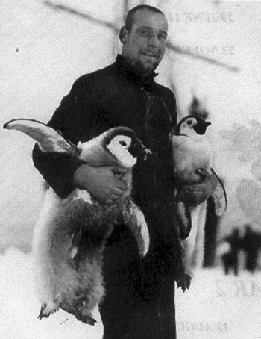

Huberht was the son of our priest. He had spent 22 months in 1914-16 trapped in ice in the Antarctic. He had been the Navigator on Shackleton’s ill-fated voyage. As soon as he had been rescued, he rushed home to serve on the “Q-ships”, the decoy vessels. In the Second World War, he was the senior serving officer in the RNR. Having been Commodore for 3 convoys to & from Halifax, he did the same number to Russia. On his next convoy coming back from Gibraltar he was torpedoed & drowned.

CHARLES ARNALL ROYAL ARTILLERY 11/08/1943
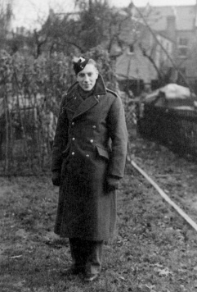 Charles was with the Royal Artillery he died on the Burma railway in 1942. His father, Charles Arnall senior, and uncle Oswald Theobald had died in World War 1.
ROLAND BEHN H.M.S. Ulster 4/10/ 1943
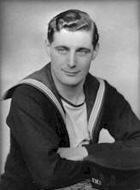
Roland was a sailor, he died in action against German destroyers in the Bay of Biscay in H.M.S. Ulster. She took a hit in the For’rard gun turret that killed Roland.
PETER ROGERS East Surrey Regiment 6/10/ 1943
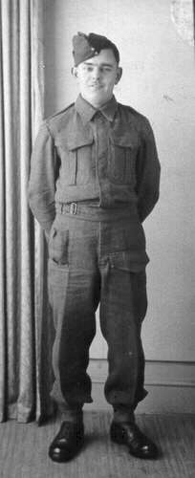
Peter was the Thatcher's son, who joined the East Surrey Regiment. He was wounded at Dunkirk but recovered to go on the "Torch Landings" in North Africa. He fell in vicious fighting in Italy near Larino, just 2 days after the villages lost Roland.
JOHN GELDARD Royal Engineers 13/2/ 1944
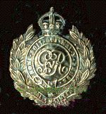John came from Ilkley in Yorkshire. He had married the niece of our Rector. He was an officer in the Royal Engineers. John was training here for the D-day assault when he came off his motorbike. He rests with Oswald and George, here at Saint Andrew’s.
STANLEY NEVILLE Essex Regiment 25/12/ 1944
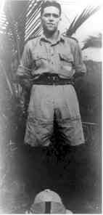

The penultimate blow was perhaps the cruelest.
Stanley, who was Robert’s brother, had joined the 2/5th Battalion of the Essex Regiment. Stanley served in North Africa and Iraq. On the 1st July 1942 , they fought the Battle of Deir-el- Shein, which was the turning point in the desert campaign that year. In fact, the Battalion was awarded it, as a Battle Honour. Stanley, with many others were captured and held in POW camps in Italy. He tried several unsuccessful attempts to escape and eventually was transferred to what is now the Czech Republic. On Christmas Day 1944, the Americans bombed the factory, where Stanley was being forced to work. Stanley lies in a cemetery in Prague.

HENRY MARSHALL Lincolnshire Regiment 23/5/1952
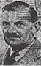

The final tragedy was Henry, who had served in Flanders throughout the First World War and had been wounded three times. Between the wars he had been "Mentioned in Dispatches" for service in Palestine. In World War Two, he had led a Battalion of the Nigerian Regiment in the Abyssinian Campaign. Post War he was given a medical discharge but still continued to serve his country, as commander of the local Home Guard. This brave man finally succumbed in 1952.

So if you visit our villages, you will see our memorial on the Village Green and at Saint Andrew’s the dedicated "Memorial Book", which tells the story of thirty brave young men and their families, that grieved .

YES, THEY WILL BE REMEMBERED.

Their stories are given in detail in the Memorial Books held at Saint Andrew’s ABBERTON with LANGENHOE.

