ABBERTON & LANGENHOE NEWS
July - September 2021

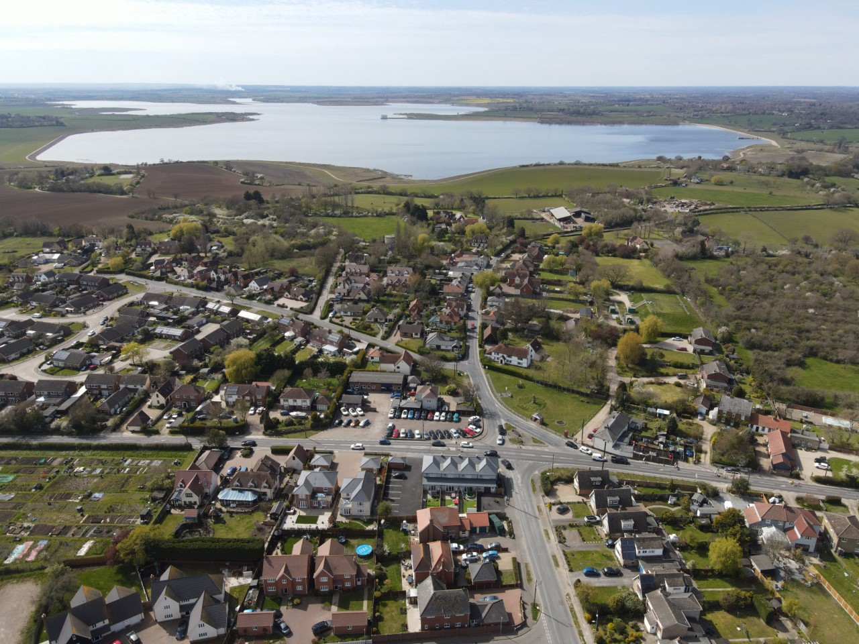

PARISH INFORMATION:
Parish Clerk: parishclerk.al@hotmail.com
WEBSITE: www.abbertonandlangenhoepc.org.uk
Abberton & Langenhoe Village Community

VILLAGE HALL ENQUIRIES/BOOKINGS:
WEBSITE: www.alvh.org.uk
Email: ALCAhallbookings@outlook.com
Phone: 735980 between 10am and 7pm
l

PACE Chartered Accountants
TAX - ACCOUNTANCY
3 THE RETREAT, GLEBE LANE, ABBERTON CO5 7NW TEL:01206-735883 or MOB:07771-511156
E-mail: louis@pacecharteredaccountants.co.uk
Web: www.pacecharteredaccountants.co.uk
- Annual accounts for sole traders, partnerships, companies – builders, retailers, doctors, dentists, contractors and consultants …. Small and medium sized business specialist
- PAYE and VAT services, payroll and bookkeeping -cloud specialist (monthly payment options)
- Tax returns and personal tax planning
With over 25 years in practice as a chartered accountant, and making full use of cloud and web-based accounting and bookkeeping services to provide and efficient, and cost-effective service to old clients and new.
No charges are made for an initial consultation of up to an hour, with no obligation. You have nothing to lose, and may get a tax or efficiency saving hint out of the meeting. Remember for personal tax returns, the filing deadline is 31 January each year, and if you can deal with it before December, you’ll avoid the pressure of last minute filing, and chances of fines after that date.

Front cover photo courtesy of Richard Palmer

FLOWERS WITH FINESSE
ADVERT
(sent separately) ½ Page

CHAPPELL ELECTRICS
ADVERT ½ Page
(sent separately)

ABBERTON & LANGENHOE
PARISH COUNCIL www.abbertonandlangenhoepc.org.uk
Abberton & Langenhoe Village Community

Chairman’s Chat…
Hello,
My how it seem to come around again so quick. Another chairman’s chat with hopefully many of the village going “ons” and news. Sitting here in my office, with the windows open and the warm air coming in, it’s great to see Summer, after a cold and wet May. Summer this year is special to us all after lockdown through the winter months.

We started this quarter by getting the steel embossed planters in position on the village triangle and my thanks to Cllr. Palmer-Slatter for getting this project so far, we look forward to seeing them full of colour soon. The Willow Tree on Abberton Green is slowly showing signs of life. The greens have been cut a number of times, our thanks to Cllr. Frost for organising the cutting.

Our last Parish Council meeting was held at the Village Hall after many months of “zoom”. We would be pleased to see residents at our meetings so feel free to come along. Also, I hope to see you on our Fun day planned for 3rd July at the Village Hall and Green between 12am and 4pm, come along and have some fun! For more details please contact Cllr. Palmer-Slatter.
On 21st April I represented the Parish regarding the proposed development on Peldon Road via a Zoom meeting and I put our views across, that we want less development on the site as requested, so we wait to see the outcome of the Planning Inspector
Mr. James Bridgewater.
Parking remains a problem around the school area and unfortunately, no real answer has been found. Some parents seem so rude and intolerant to resident’s homes and driveways, as do some residents towards the parents. Lines, in any colour, will maybe help to remove the problem elsewhere, but the school is there and on cold and wet days issues will arise, please all be tolerant.
Once again many thanks to the Lion Shop Committee and to the shop volunteers. If you feel you would like to volunteer please ask in the shop for details, full training will be given and you will never be left alone in the shop.
While summer is here, please make the most of our outdoor gym equipment and learn to play pétanque with friends/family, these are wonderful facilities.
Litter picking continues with Bridget, Sue, Graeme, Lin and Eric being our great Litter Warriors - thank you for keeping our village clean. Unfortunately, there are a few irresponsible dog owners who don’t pick up after their dogs which is such a shame, especially as we have four dog bins in the village. The Zone Warden, Tim Pickard can be contacted to report this offence and the dog owner can be fined, his number is 07967692030.
On May 10th we held our Annual Meeting outlining past events, accounts for the year and I was elected Chairman for another year, my thanks to fellow Councillors for their support.
Sadly it was reported, over the last few months, the death of long-time residents Linda May and Katie Richardson.
When I next report hopefully harvest will be over with the Linseed (mauve) having been cut, the wheat harvest in, straw cleared, and the Maize cut and stored.
That’s it for now I’m off to mow the hay.
TTFN.

Steve Wormell
Cllrwormell@gmail.com

You are very welcome to join our Parish Council meetings starting at 7.30pm at the Village Hall.
Please go onto our website for further details: www.abbertonandlangenhoepc.org.uk
or Email our Clerk: parishclerk.alhotmail.com

If you would like to advertise in this newsletter please contact the Editor:
Margaret Palmer-Slatter: cllrpalmerslatter@gmail.com

Abberton & Langenhoe Neighbourhood Watch
A word from Stephen Armson-Smith, Essex Police Heritage Crime Prevention Lead:
Your Heritage and Culture needs you.
We have spoken of metal theft before, seeing it in many forms i.e. the theft of catalytic convertors from the exhaust system on cars and vans, lead from roofs old and modern rural and urban, cabling for utilities such as telecommunications and many other examples from around us where there are valuable metals. We are seeking those extra pairs of eyes to report anything that you believe is suspicious.
The country and our county are full of a wealth of heritage and culture each telling a story of our past. Our heritage and culture have been there for past and present generations to discover, enquire, learn from and enjoy and we need to protect it for future generations. These heritage assets cannot be replaced.
Heritage crime comes in many forms, these are but a few:
- The theft of lead from a roof causes catastrophic damage to a church of other heritage building potentially also causing the cancellation of a wedding or other function.
- Theft of paving stones, bricks, and other architectural masonry.
- Monuments and memorials suffer from damage, and theft, often of metal plaques bearing the names of events of those recognised.
- Royal mail post boxes many unique and recognised from a specific period in time are stolen.
- ‘Nighthawking’ the theft of archaeological material by unlawful metal detecting.
- Graffiti to heritage structures.
Some locations will be isolated, some may have neighbours, visitors, passer-by’s, dog walkers, horse riders, hikers and more; anything suspicious report it to: staff or the police using 999 if it is a crime in progress or 101. Don’t know where you are use the “What Three Words” App https://what3words.com/products/what3words-app/ police and other emergency services use it.
Making it more difficult to steal or dispose of:
- Report any suspicious activity: i.e. the car or other vehicle parked up in a suspicious manner or seemingly out of place. NB – If you have planned building work let your neighbours know including who they are and when they will be there.
- Make it harder to steal: Consider electronic security and CCTV.
- Making it harder to dispose of: Property marking makes it harder to dispose of. NB seek advice and the relevant authorities before marking heritage items. A thief will know this and therefore anything that ties it back to the owner presents a risk not only to the thief but also to the handler.
- If you are buying a piece of history, heritage stone, architectural masonry etc. question its provenance, where it came from, legitimacy of the seller, if in doubt report it to Trading Standards or the Police.
For further advice on heritage crime and crime prevention see: www.essex.police.uk/cp/crime-prevention/ or https://historicengland.org.uk/advice/caring-for-heritage/heritage-crime/

I am holding our first face to face meeting on Monday 20th September 2021 at the village hall. All those attending there will be refreshments and after all this time a minor celebration! Everyone is welcome to attend subject to the rules at that time. I have decided to postpone the proposed meeting on 21st June 2021 as it may well be the first day of full lockdown restrictions being lifted.

We urgently need to increase our membership and include all those new to our villages. Our scheme also needs many more co-ordinators.
Please ring or email me if you would like to sign up.

My contact details are: 01206 735683 or sue@kingandco.co.uk.

Sue King
Chair Abberton and Langenhoe NHW
___________________________________________________________

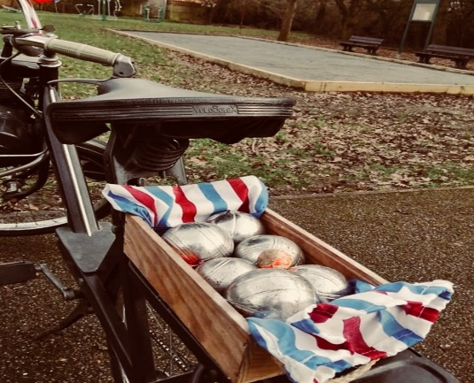

Villagepetanque@yahoo.com
Have you had a go yet? It’s great to see residents enjoying this new facility.

LADIES CIRCLE
Members will be notified individually of any planned arrangements for reopening.

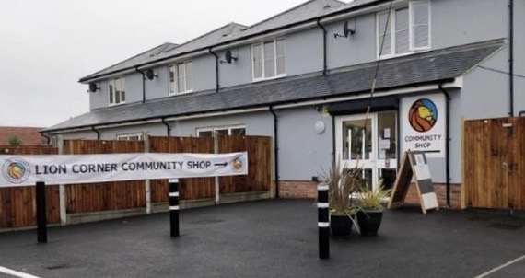

Lion Corner Shop Phone Number: 07708 403292
Happy Summer Everyone!

The Lion Corner Shop is going from strength to strength – a lifeline during the Pandemic, but with the easing of restrictions we hope that residents will continue using the shop as it also aims to be a small hub for a friendly chat along with the purchase of a tin of beans (or a chocolate bar or an ice cream whichever you prefer!)

Customers will have noticed that we have two additions to the front of the Shop – a bench kindly built and donated by Jim Waterhouse and a second bench donated by Alex Miller – very handy if you want to soak up the sun for a few minutes, even better with an ice cream or a hot/cold drink, or all three!

Lion Corner is a Community Shop so we like to support our local businesses where we can and the Shop now hosts a selection of wines and beers from Mersea Vineyards. I have tried the 'Mehala' dry white wine and it is delicious, especially when sitting in the sun in the garden – hopefully we will all be able to get into the garden now!

We can now offer fresh bakery products from Mersea Bakery on a Monday as well, so if you would like to make sure your favourite loaf is available pop into the shop and fill out a form to reserve, easy as that! Very handy if you have packed lunches to make up or a picnic planned, the sausage rolls are great too.

A big thank you goes out to our volunteers who have weathered the weather and the Pandemic to keep the shop going, we couldn't do it without you.
On that note, if anyone would like to volunteer but thinks it too daunting or cannot commit to a regular shift - worry ye not – we have a group of volunteers that are 'ad hoc' and we value them as highly as the regulars. Full training will be given and supervision can be arranged until you get used to the ropes. Don't want to work in the shop but feel you would like to 'do your bit'?

We are always looking for helpers in other areas too. Maybe you could order and pick up the eggs from Stanway or take over other ordering to cover holidays (when we are allowed to have them again!) There are lots of ways to help. Just email Maggie at volunteeringalcs@gmail.com to find out how you can get involved.

In the last newsletter I included some anagrams to get you thinking about what we stock in the shop, this time I have included some Link Words (with a very tenuous link to shop items) – see if you can work out the word that links the other two:
APPLE - PASTRY
WINE - BANK
BEER - OPENER
WATER - POND
CHOCOLATE - CRUMB
SOAP - PUFF
CHINA - POT
OAT - SHAKE
SPONGE - BASIN
TOFFEE - PIE
Jenny Turtill
Community Engagement for ALCBS (Answers on Page 15)

********************************************************************************************************

WE’RE MEETING AGAIN !!

The Meeting Place
Is restarting on
Wednesday 21st July
10am to 12 noon
Village Hall

We look forward to seeing you all again for a coffee/cake/chat – all welcome

Subject to current government guidelines of course.

ABB
ERTON & DISTRICT CRICKET CLUB

Hello!

Luckily, after many weeks of rainfall in May the weather has changed for the better, and as I write the sun is shining!

Our groundsman Craig Scott, despite having to contend with a wet start to the season, has as usual, done an absolutely fantastic job in creating one of the finest playing surfaces in the County. Many visiting team have praised his work – thank you Craig.

The season has also seen some major improvements in terms of facilities for the players. The recently installed practice nets area has now been taken into use, replacing the old nets that were long overdue for replacement. A new bowling machine completes the now fully enclosed facility.

The match programme is now well under way with fantastic availability from members wishing to play and some very enjoyable games are being played, although we have not won many games so far this season.

Friday evenings see huge activity at the ground where Colts training is fully under way. There are now some 80 Colts members enjoying the training programme provided. There are now some 17 girls signed up to the” girls only” Essex Cricket Board’s Dynamo’s Course.

A number of villagers have renewed their Social Memberships to enjoy what is now the only licensed facility in the area. If other villagers are interested in joining, Social Memberships are just £20 per annum – please email me and I will make arrangements for your membership. One other item ,if any resident has a Company they would like to promote on a Club boundary board, again please email me and I will put you in touch with my colleague.

On behalf of the Club Committee we wish you all an enjoyable summer.

Best regards,

Doug Kibblewhite

ADCC
douglas.kibblewhite@btinternet.com

FANCY A GAME OF CARPET BOWLS?

The Carpet Bowls group are hoping to reopen at the Village Hall as soon as the government guidelines allow, hopefully in the very near future.
They are looking for new members of any age and ability. Your first three visits are free so please think about coming along when they meet again at the Village Hall on Wednesday evenings and Friday afternoons.
A friendly welcome awaits you.
So if you would like to know more please contact either
Tim on 735520 or Tony 735466
************************************************
T
Thank you to all have used our wonderful Book Swap over the past months, it has been very handy especially during lockdown.

ALL WE ASK IS PLEASE DON’T PUT BOOKS ONTO THE FLOOR AS THEY GET RUINED. Thanks.

ARE YOU CRAFTY?
The monthly Craft Mornings are restarting on
Thursday 1st July between 10am and 12 noon.
For more information contact Chris on 735071
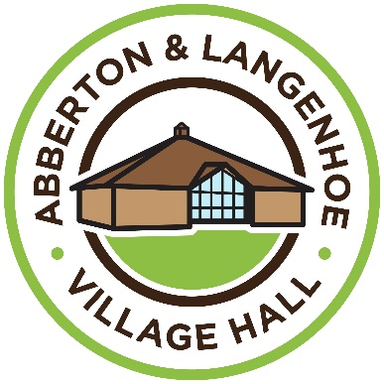
Website: alvh.org.uk
Email: ALCAbookings@outlook.com

After the disaster in January when our hot water tank over flow froze in the cold weather leading to the flooding of our main 440 Volt electric trips and fuse box, not the best thing that could have happened considering we haven’t been operating or taking any money for the last 15 months. We are now going to move the hot water tank well away from our electrics as we do not want the same problem this coming winter. Moving the tank is not a simple operation so as the tank is over 25 years old we have decided to put in a new smaller one

The hall is slowly opening again with the Dynamite School of Dance being one of the first and proving to be very popular with the youngsters, Sarah Harding has also won Dance Tuition Service of the Year for London and the South East, well done Sarah.
Yoga classes have restarted on Mondays 5.30 - 7pm, if interested give Caroline a call on 07760 237419.
The popular Parent and Toddler Group will be returning 25th June on Friday mornings for 0-4year olds if interested call Emily on 07599 709509.
Please support our Fun Day (see opposite page) Proceeds from the event will go towards the Village Hall funds. It’s also a great chance to meet and catch up with your neighbours and friends after 15 months!
We are also pleased to announce that The Meeting Place is going to reopen on Wednesday 7th July! We’ve all missed this very popular Coffee Morning and we look forward to welcoming you all back, obviously within the current guidelines, but we can meet!
On Saturday September 11th we hope to have the previously postponed Abba Chique tribute band, they are one of the best Abba tribute bands and have lots of good reviews. See the back page of this newsletter for further details.

I look forward to seeing you all soon.
Alan Frost
Chair Aberton & Langenhoe Community Association

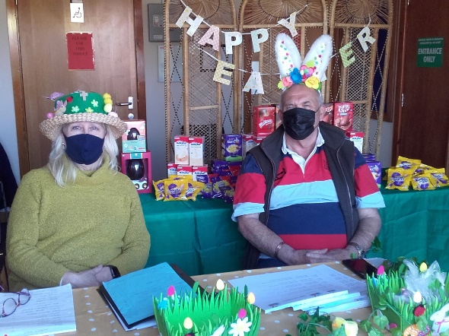
Thank you to everyone who came along on a beautiful sunny afternoon on Sunday 4th April to hunt for Rabbits hiding in residents windows around the village.
There were also clues for the older children.
We gave out 62 eggs!
Village
Fun Day
SAT. 4th SEPTEMBER
12 noon to 4pm
Langenhoe Village Green
BBQ - Bar - Games - Stalls – Grand Raffle – Tombola – Animal Petting Corner –
Children’s Dance Display
and lots more!

Come along and have some fun!

CAN YOU HELP?
Donations of items e.g. chocolates, wine, new gifts for adults and children for our tombola will be gratefully received. Please take along to the Lion Shop and place in the box provided – Thanks.

Clues across:
1 Describe the nature of crazy erratic chase. (12)
7 Madagascan resident involved in vile murder. (5)
8 Soldier in charge left directions by the bank in Rowhedge. (5)
9 Label is strange with odd letters missing. (3)
10 You are generally happier if they pass you. (9)
11 Take possession when company returns trophy at the end of July. (7)
12 Government gets army corps to take in US soldier. (6)
15 Musical starts to make advances. (9)
17 Party at last spot. (3)
18 American returns with his weird fish dish. (5)
19 We hear numbers of sheep could be seen in the garden. (5)
21 Parties seeing Cabinet’s role differently. (12)

Clues down:
1 A cost to a Scot moving from Blackpool to Bridlington for example. (5,2,5)
2 Get weapons right in the morning. (3)
3 Concerning that encircling menace. (6)
4 Radios are used to sort out financial problems. (9)
5 Second crazy love – work it out! (5)
6 Softly and awkwardly creep into St Ives to show points of view. (12)
7 Good sense to write down one condition first. (5)
10 Feel for Eastern politician upsetting his tea. (9)
13 Possibly the last thing you would expect to see in a book. (5)
14 Support Her Majesty in the right way. (6)
16 Happen after seen shuffling round bend. (5)
20 A great many seen at auction. (3) (Answers on page 15)

CHARITY OF EDWARD MARKE

(Reg. No. 239476)

We now have a full complement of allotment holders, that’s got to be a first for a long time!

What with the rain and then the sun the weeds are doing well but I am sure with all the effort put in by the allotment holders most will be eradicated.

Vegetables are starting to grow and Dexter is doing a great job keeping on top of the grass cutting, hopefully we can get back on track as we have had no meetings since COVID as some of committee members don’t do zoom.

There are lots of improvements that have been held up, raised beds are still on the agenda but wood has gone up by 30% ! We hope to also have a shelter if it rains and maybe a storage container to store some tools.

Later in the year we would like to have an allotment Open Day, we did this 3 years ago and proved very popular with the
residents.

If you would like to join the waiting list for a half plot please
contact me.

Alan Frost

Chair - Charity of Edward Marke Trust
Mobile 07710794885
cllrfrost@gmail.com
Crossword Answers
Across
1 Characterise, 7 Lemur, 8 Colne, 9 Tag, 10 Examiners, 11 Occupy, 12 Regime, 15 Overtures, 17 Dot, 18 Sushi, 19 Phlox, 21 Celebrations.
Down
1 Coast to coast, 2 Arm, 3 Threat, 4 Receivers, 5 Solve, 6 Perspectives, 7 Logic, 10 Empathise, 13 Index, 14 Proper, 16 Ensue, 20 Lot.

LION SHOP ANSWERS: puff, bottle, can, lily, biscuit, powder, tea, milk, pudding, apple

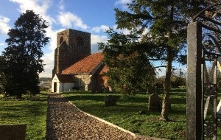
ST. ANDREW’S CHURCH ABBERTON

Benefice Administrator: Malcolm Hawksby
Tel: 01206 729638 or 07763 955684
Email: malcolm.hawksby@gmail.com.

Church Warden: Pepeta Dutton
Tel: 01206 735424

Places of worship across England are praying that Prime Minister Boris Johnson holds his nerve and lifts the remaining coronavirus restrictions on June 21st – ‘Freedom Day” - rather than bowing to pressure to delay the end of lockdown by a fortnight until July 5th.
Removal of constraints on social contact, the wearing of face coverings and singing of hymns would be the most-uplifting signal of life beginning to return to normal.
Until the first national Covid lockdown in March 2020, Abberton, Fingringhoe and Rowhedge churches had managed, with the support of retired and other clergy, to provide the same number and regularity of Eucharists each month as before the parishes fell into vacancy with the departure of their incumbent, Revd. Patrick McEune, at the end of August 2018.
However, this proved unsustainable as the pandemic developed and its consequences took their toll. The most incapacitating of these operationally were the social distancing rules, and difficulties in sourcing locum ministers. Some, being among individuals most at risk of infection, wisely self-isolated; others cancelled due to non-Covid related illness, while yet others had to prioritise the needs of their own churches and withdraw from commitments to help local churches in vacancy.
In the circumstances, our benefice had no choice but to cut our coat to fit our cloth: Abberton and Fingringhoe closed for public worship, though remaining available (when Government and Church of England guidance permitted) for baptisms, weddings and funerals; and the worship schedule was reduced to two Eucharists and two lay service a month, all at St. Lawrence’s, Rowhedge, the one church with capacity to seat all three congregations within the rules on social distancing.
That arrangement has been operating for the past year and will be reviewed by the Parochial Church Councils of the three churches in the light of whatever guidance is given to places of worship by the Government and Church of England for life beyond June 21st.
Sadly, one much-loved, valued and dedicated member of Abberton’s worshipping community will be absent when we are able to gather once again at St. Andrew’s, Katherine Richardson, who served as a churchwarden alongside Pepeta Dutton in recent years, died, aged 65, at St. Helena Hospice on 13th April after a long illness. Shortly before her death, she and her partner, Paul Massey, were married. Her funeral took place at Colchester Crematorium on 17th May and she is buried in St. Andrew’s churchyard. All who knew Katy will miss her greatly.

Mrs. Sarah Stevenson
Headteacher
Langenhoe Community Primary School
Bracken Way
Abberton
Colchester CO5 7PG
Tel: 01206735267
E.mail: head@langenhoe.essex.sch.uk

Dear Residents,

It has been a challenging few months for the school as we have worked our way through another Lockdown. It has been made especially difficult because several staff members and their families have had Covid. We have been very grateful for all the support and good wishes we have received from all our families.

We have reflected on the previous Lockdown and what went well and, as a result, adjusted our Remote Learning Policy. This time we have been delivering daily live sessions and a weekly whole school assembly via Zoom. We are very proud of how all our children and their families have adapted so well to new ways of learning. The school has remained open for our families who are Critical Workers, and it has been a privilege to continue to support them.

One of the villagers, Simon Levene, very kindly supported us by donating devices to help those families who were struggling to get online. It has made a big difference to them and has meant they can join in with our remote learning.

The school had its 25th Anniversary in December but we postponed any celebrations until the summer term when we are hoping we will be able to invite other people from the community to celebrate with us.

We are hoping that soon we will be able to welcome all our children back into school. We have missed them all very much!

Hope you are well. Keep safe.
Kind regards

Sarah
ABBERTON & LANGENHOE
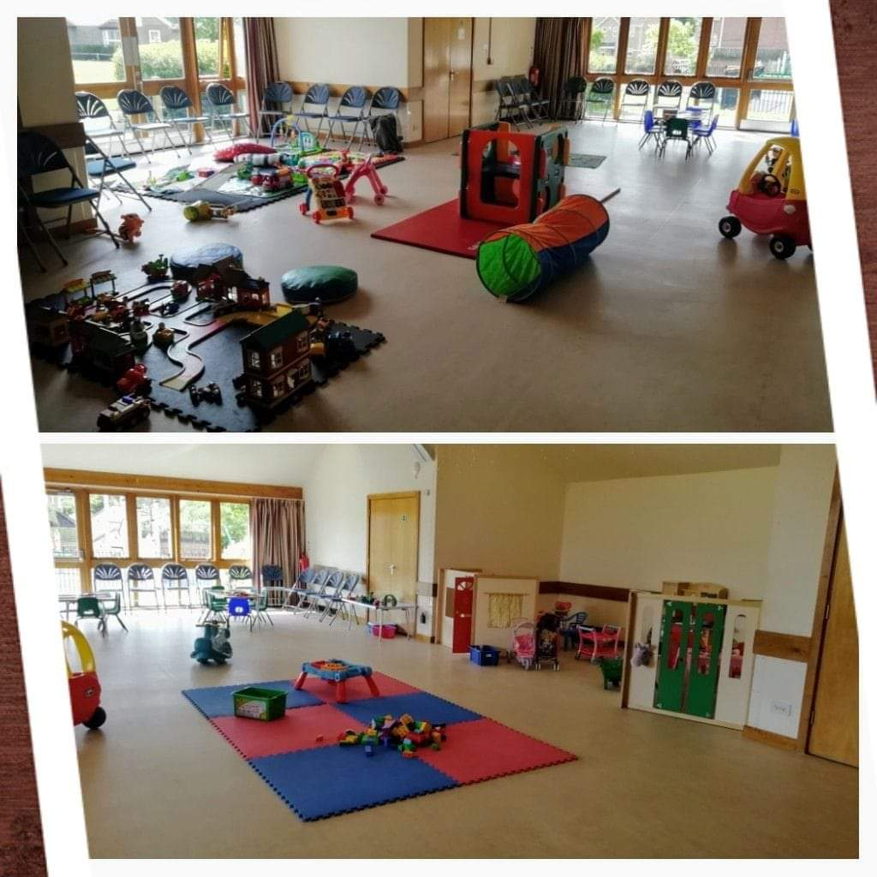
PARENT & TODDLER GROUP
STARTING AGAIN ON 25TH JUNE

an informal drop in

session for 0-4 year olds

Fridays 10-12

£2 for under 1 year olds

£4 for 1 years and over

Includes free play, craft

activities and REFRESHMENTS

Abberton and Langenhoe Village Hall

Contact Emily for more information: 07599709509

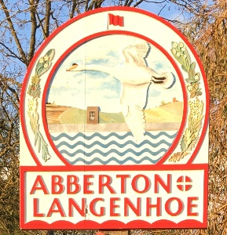

The eagle-eyed among you may be wondering why our lovely Village Sign disappeared?

Tom Mabbitt, who is the original carver and painter of the sign, has repainted it.

Tom was born and lived in our village for 70 years along with his wife Rosemary. Tom was a warden at
St. Andrews Church for over 40 years and was also a Parish Councillor and Rosemary taught at Langenhoe School. They were both very much involved with fundraising for our Village Hall and Tom was Chairman of the Community Association for many years. Before they left our village they continued to support Langenhoe School, Ladies Circle, St. Andrews Church and the Toddler Group! Sadly, Rosemary is no longer with us, but their contribution to our village life will never be forgotten by all those who knew them.

**********************************************

WORMELL ADVERT ½ page
As previous issue

PLEASE USE LAST ISSUES ADVERT

PLEASE CENTRE THIS ADVERT
www.stabilisfitness.co.uk 1-1 Coaching
Whether your goal is to get fit, lose weight, train for a specific event, tackle mental and/or physical health issues or simply to get the most from your fitness and nutritional regime, then you’ve come to the right place.
My philosophy is that success comes from hard work and although I expect all my clients to commit to their program wholeheartedly I understand that at times life can get in the way and this is where I will be there for you to advise and guide.
I can assure you it will be worth it!
If you’re interested in working with a Health & Fitness Coach then it’s important to understand that these can offer very different services.
Most trainers concentrate on the hour in the gym however what about the others areas such as Nutrition, accountability whilst away from you and mindset?
At Stabilis Fitness I remain focused on a holistic approach to mental and physical well-being, making lifestyle adjustments to help my clients reach their targets and enjoy ongoing benefits.
Every new client receives a thorough assessment covering physical health, posture, fitness levels, mental health and nutrition. Once I know exactly where you are, we can discuss the best way to take you where you want to go…
Your bespoke training schedule will be designed to work in conjunction with your lifestyle, making positive changes to benefit your long-term health and fitness.
All memberships come with the following:
- Use of a fully equipped private studio with air-conditioning and complimentary water, temperature checks, hand sanitizer, all equipment wiped down on each session.
- Access to our interactive app and computer-based software
- Video and written instructional custom-designed training program with mobilisation and stretching protocols based on your goals, commitment, and lifestyle, accessed in any gym, anywhere in the world including educational videos and pdf’s to allow you to gain life-long knowledge.
- Plans updated each month
- Education on how to manage your caloric intake for fat loss
- Access to our in house nutritionist
- Advised meal plans and recipe books with caloric daily targets as well as macro-nutrient breakdown based on your goals.
- Fitness and body statistic assessments
- Body fat reduction
- Weight management
- Muscular gains
- Specific physical activity goals
- The opportunity to become fit and live a healthier, manageable life
- Exercise safely through proper form and adequate rest
- One to one training and guidance
- Tone and reshape your body
- Improve flexibility and stretching
- Access to the Facebook private members page
- Personal support and motivation with a two-way message facility and unlimited text/email
- Access to the Stabilis Fitness community – building relationships
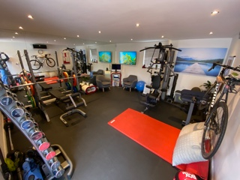

My clients are able to use the fantastic facilities at my private strength training studio with state-of-the-art equipment, complimentary water, and hand sanitizer on
Mersea Road in Langenhoe.

Many of my clients also use other gyms or do my home workouts when away from me using their fitness apps which fully house their training programs, nutrition, educational tools, and much more.

Full page advert
COLCHESTER ASBESTOS
(as per last edition)

ABBERTON & LANGENHOE COMMUNITY ASSOCIATION PRESENTS:

Appearing at our Village Hall on
Sat. 11th September Starts 8pm (doors open at 7.30pm)
Bring your own drinks/nibbles
Ticket only event £15 to book phone 735980
70’s dress optional – prizes for best dressed male & female
ABBA Chique are the hottest tribute to ABBA! This full time professional and authentic tribute band have been performing since 2009 for all sized events, all over the UK and abroad. Check them out at: www.abbachique.com
Subject to Government current guidelines of course.

